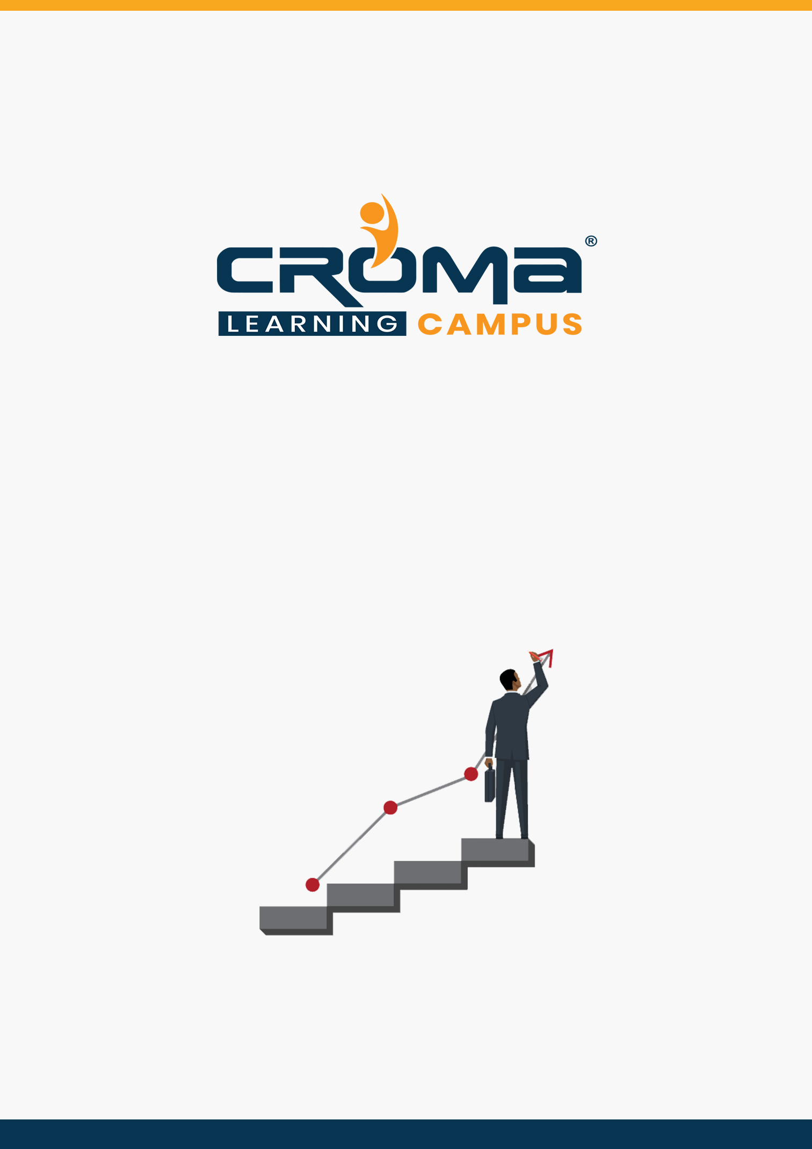

**SAP Analytics Cloud (SAC)**

**Training Curriculum**

**STRUCTURE**

**www.cromacampus.com | helpdesk@cromacampus.com | +91-120-4155255**

**SAP Analytics Cloud (SAC) Training Curriculum**

*“Get in-depth knowledge of SAP Analytics Cloud and make yourself stand out in the crowd.”*

**Course Objectives:**

* Get in-depth idea of every area of SAC with hands-on exercises in most.
* Know about BI functionality and building and navigating in stories with an additional focus on Digital Boardroom.
* Learn practical concepts of the product and know how to kickstart your project at your workplace.
* Prepare yourself for the SAC global certification exam and get recognition
* Apply for leading MNCs and get hired by top industries across the world.

**About SAP Analytics Cloud**

Analytics Cloud is a software-as-a-service (SaaS) offering that provides all the analytics capabilities for all users in one product. The Analytics Cloud solution helps all types of decision makers who need to make better decisions, by combining business intelligence, collaborative enterprise planning, and augmented analytics.

Rather than relying on standalone spreadsheets or separate, disconnected reporting and planning tools, everyone has everything they need, embedded where they work, to make confident decisions together and become a more agile, intelligent enterprise.

**Course Description:**

Croma Campus offers the best SAP Analytics Cloud Training in Noida India with most experienced professionals. Our Instructors are working in SAP Analytics Cloud and related technologies for years. We aware of industry needs and we are offering SAP Analytics Cloud Training in more practical way.

Our training will be handled in either weekday or weekends programme depends on participants requirement. If you are working on SAP Analytics Cloud and facing any problem while working on it then we are just a Call/E-mail away to help you. We provide SAP Analytics Cloud Online Job Support for professionals to help them solve their problems in real time.

Our SAP Analytic Cloud Training Course is intended for:

* Business Users
* Data Analysts
* Application Developers
* Financial Planning Consultants
* Anyone who is interested in learning Analytics Cloud

Moving ahead, check out our course content and contact our expert team if you have any doubts.

All the Best!

**Course Content:**

**Module 1: Overview and Positioning**

* Analytics Cloud Architecture Overview
* SAC vs other BI tools
* Benefits and core functionalities of SAC
* Cloud vs On-Premise vs Hybrid
* Analytics Cloud Client tools and Importance

**Module 2: Connections**

* Connections Overview
* Live Connection
* Import Connection
* Connect and Assess Flat Data Files
* Connect and Assess Cloud Apps
* Connect and Assess Cloud databases
* Connect and Assess Cloud SAP HANA

**Module 3: Modelling**

* What is MODEL?
* Components of MODEL
* Working with Dimension and Classification
* Configuring Geo-Dimension
* Working with Measures
* Working with Transformations
* Working with Variables
* Data Blending

**Module 4: Business Intelligence**

* Designing SAC Stories
* Working with Custom Templates
* Working with Standard Templates
* Working with Canvas-Responsive and Grid modes
* Working with Designer (Builder panel, Styling Panel)
* Filters in SAC
  + Query level filters
  + Story level filters
  + Page-level filters
  + Widget level filters
  + Advanced Filters
* Linked Analysis
* Hyperlinking
* Conditional Formatting
* Customizing Measures
* Customizing Dimensions
* Data blending
* Widgets in SAC
  + Working with Chart widget
  + Working with a Table widget
  + Working with Geo Map widget
* R language basics
* Generating R based Stories
* Import data connection from Google drive

**Module 5: Augmented Analytics**

* About Augmented Analytics
* Smart Search
* Smart Discovery
* Smart Insights

**Module 6: Planning with SAC**

* How to develop planning data models in SAC?
* Understand measures, accounts, hierarchies, currency conversion
* Manage versions of planning
* Create planning stories
* Planning functions – variance, forecast, version management
* What if analysis in SAC
* Allocations
* Spreading and Distributions
* Value Driver Tree- VDT
* Data actions and insights
* Live Data connection to BPC system
* Collaboration

**Module 7: Analytics Designer**

* What is Analytics Designer?
* Difference between SAC Stories vs Analytics Designer
* Analytics Designer overview and walkthrough
* Outline, Designer, Error, and reference panels
* Design mode vs Run mode vs View mode
* Designing basic Analytic application
* Working with Container widgets
* Implementing filters
* working with Drop-down, Radio button, Checkbox components
* Working with script variables
* Working with script objects
* Configuring and implementing Dynamic Visibility
* Implementing Hyperlinking and Explorer option
* Using APIs to integration with Smart discovery, smart insights
* Embedding the webpages inside the Analytic designer
* Embedding SAC app inside other webpages
* Live Data connection to Application Program ON HDB for integration
* Close loop scenarios with OData Integration

**Module 8: Predictive Scenario**

* Predictive scenario overview
* SAC Stories vs SAC Applications vs SAC Predictive
* Working with Datasets, Variables
* Understand Regression
* Understand Logistic Regression, RoC Curves, AUC Curve
* Model performance and Confusion Matrix
* Profit Simulation for Classification
* Implementing Classification Precative Model
* Implementing Regression Predictive Model
* Residual and MAPE Concept in Regression
* Trend, Cycle, Residual and Variations concepts
* Implementing a Time series Predictive Model
* Generating predictive stories

**Module 9: Administration**

* SAC Administration Overview
* Roles (Standard vs Custom)
* Team
* Users
* Working with data loading and scheduling
* Cloud connector
* Analytics Cloud Agent

**Module 10: Placement guide**

* What is an Interview?
* Tips to clear an Interview
* Common Interview questions and answers
* SAC Interview Questions and Answers
* Resume Building Guide
* SAC career roadmap and certifications
* Attempt for SAC Global Certification Exam
* Start applying for Jobs